**Capstone Project:**

**ICIN Bank**

**Document contains:**

* Project and developer details
* Sprints planned and the tasks achieved in them
* Core concepts used in the project
* Links to the GitHub repository to verify the project completion

**Project and developer details**

**DESCRIPTION**

**Create a dynamic and responsive Java online banking web application to deposit, withdraw, and transfer the money between the accounts.**

**Background of the problem statement:  
ICIN is one of the top banking firms that accepts deposits from the public for the purpose of lending loans to the public. It also invests an amount in securities.  
Recently, the business analysts noticed a drop in the number of customers of the bank. They found out that online banking systems of banks like AXIS and American Express are gaining more profits by eliminating middlemen from the equation. As a result, the team decided to hire a Full Stack developer who can develop an online banking web application with a rich and user-friendly interface.  
You are hired as one of the Full Stack Java developers and have been asked to develop the web application. The management team has provided you the requirements and their business model so that you can easily arrange different components of the application.**

**Features of the application:**

**Registration**

**Login**

**Account transactions**

**Transfers**

**Savings details**

**Profile settings**

**Requesting cheque books**

**Admin Portal:**  
**It deals with all the back-end data generation and product information. The admin user should be able to:**

**Authorize the roles and guidelines for the user**

**Grant access to the user regarding money transfer, deposits, and withdrawal**

**Block the user account in case of any threat**

**Authorize the cheque book requests**

**User Portal:**  
**It deals with the user activities. The user should be able to:**

**Register or log in to the application to maintain a record of activities**

**Deposit and withdraw money from the account**

**View transactions and balance in the primary and savings account**

**Transfer funds between different accounts and add recipients**

**Request cheque books for different accounts**

**Developer Details**: Mogili Santhi

Santhimogili3@gmail.com

**Sprints planned and the tasks achieved in them**

There are four sprints for this project

Sprint-1: Studied the Features of application and created Git Repository.

Sprint-2: ICIN Bank backend created using spring boot and tested backend API

Sprint-3: ICIN Bank frontend created using spring boot and connected with backend.

Sprint-4: ICIN Bank application all features is tested.

**Recommended technologies**

Database management: MySQL

Backend development: Java programming, Eclipse, Spring Boot

Frontend development: JSP, Angular, Bootstrap, HTML/CSS.

**Output**

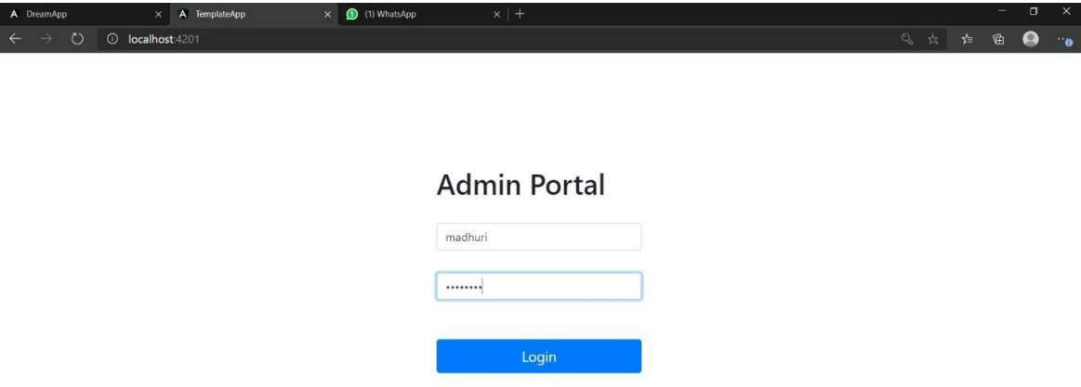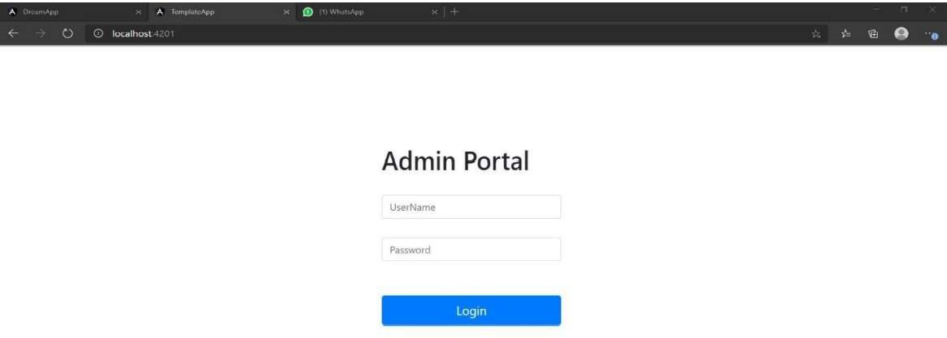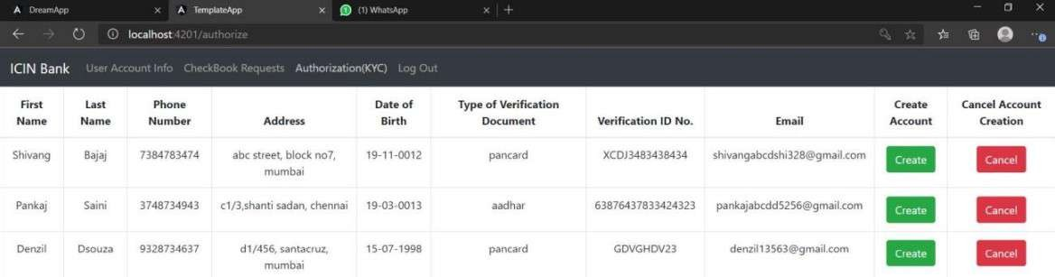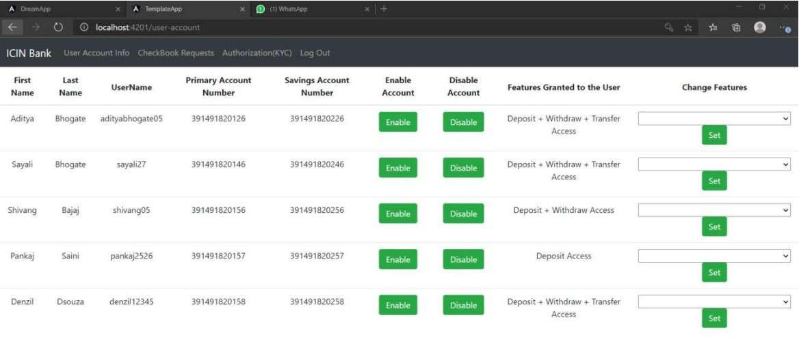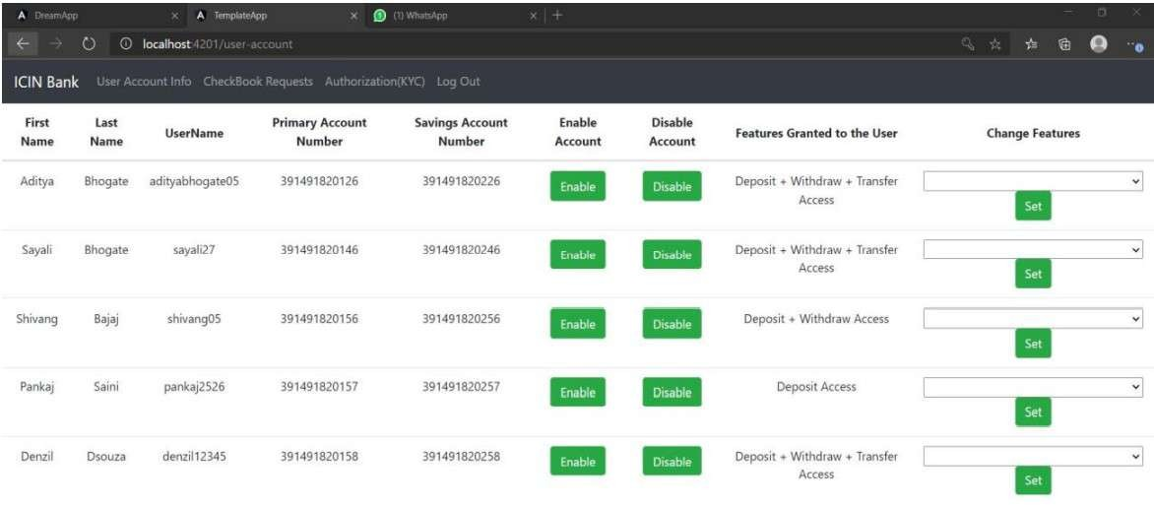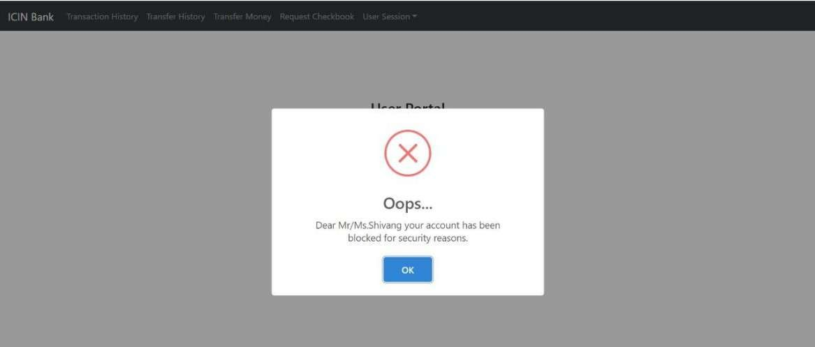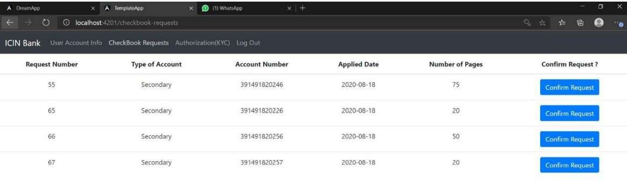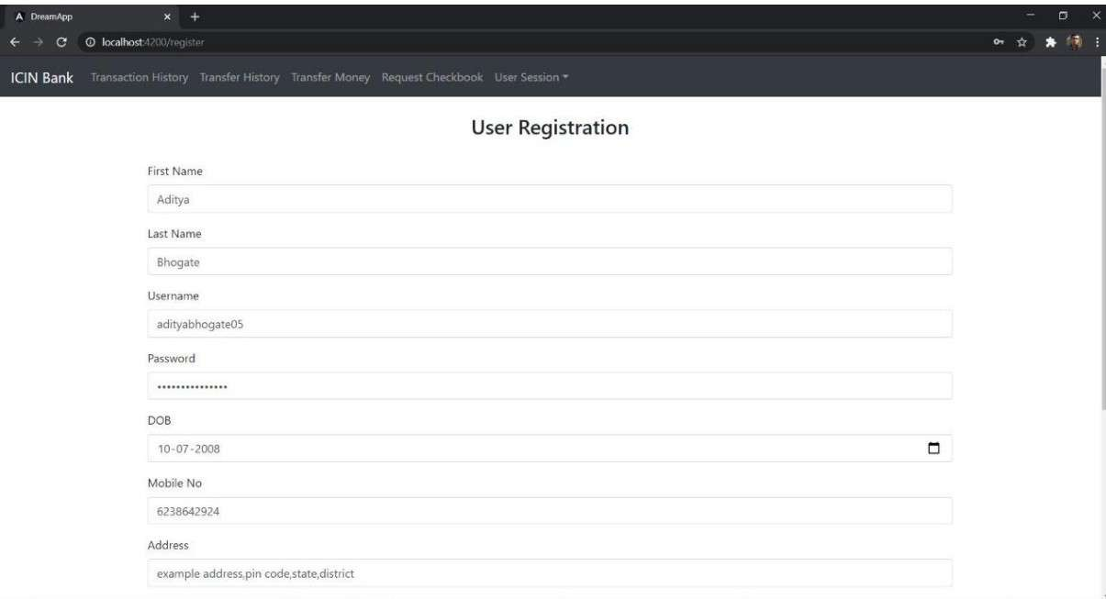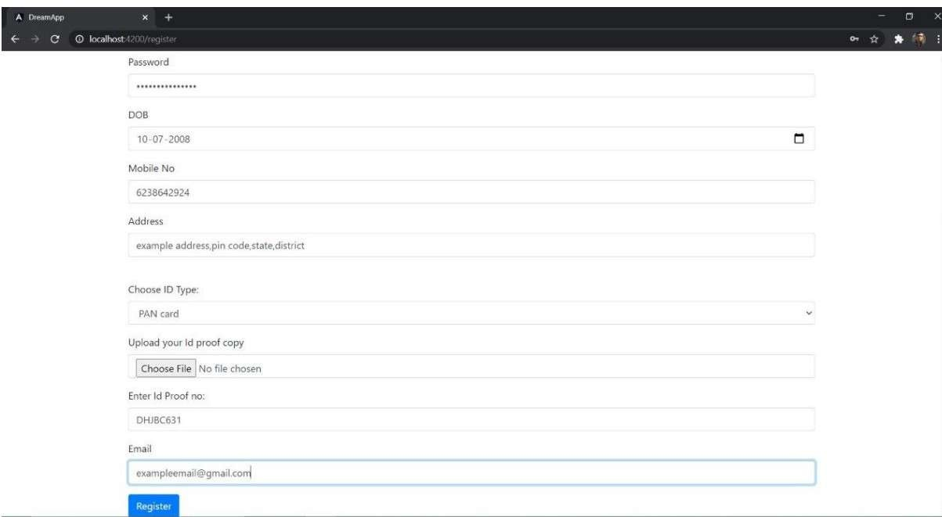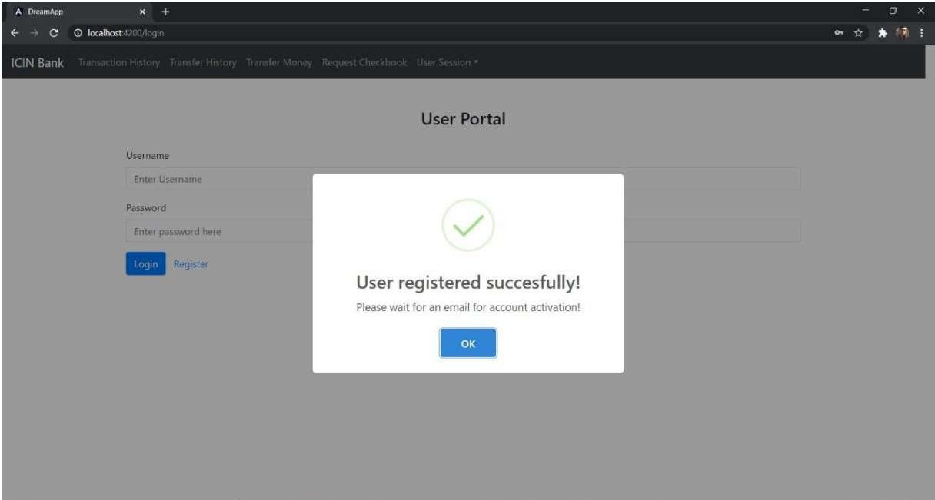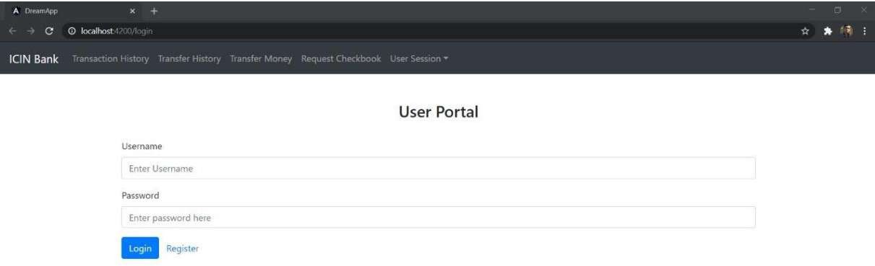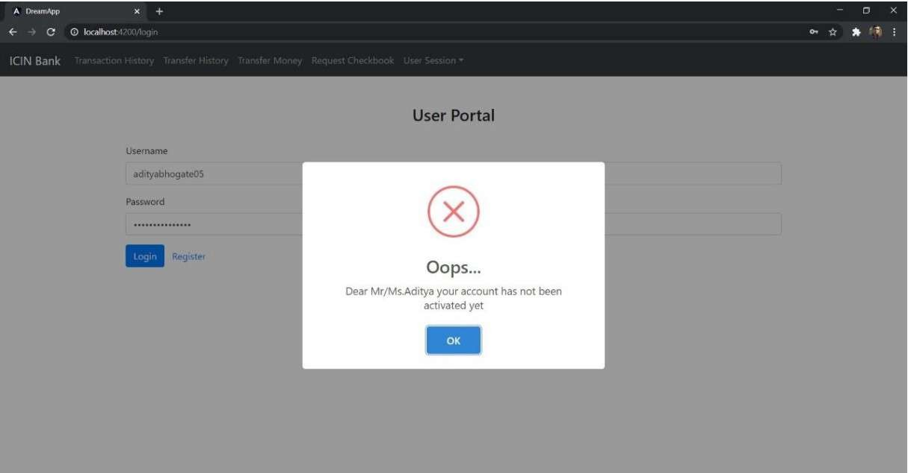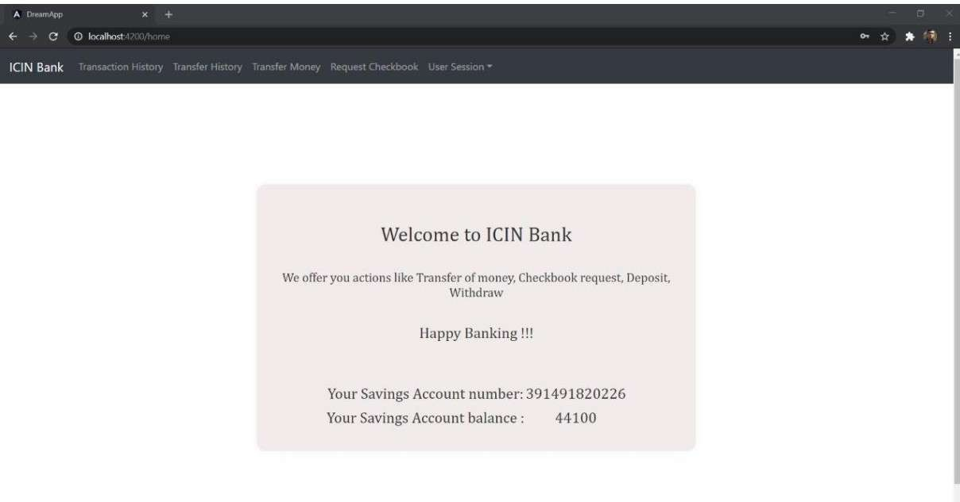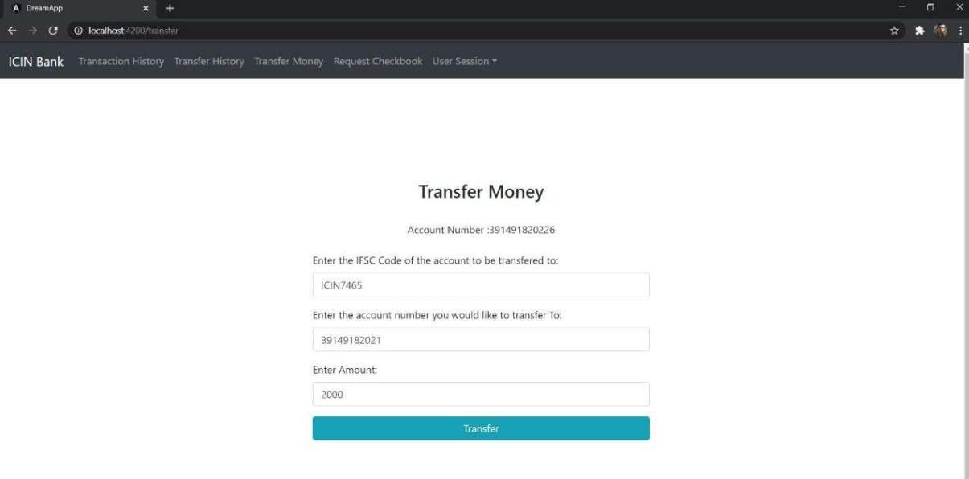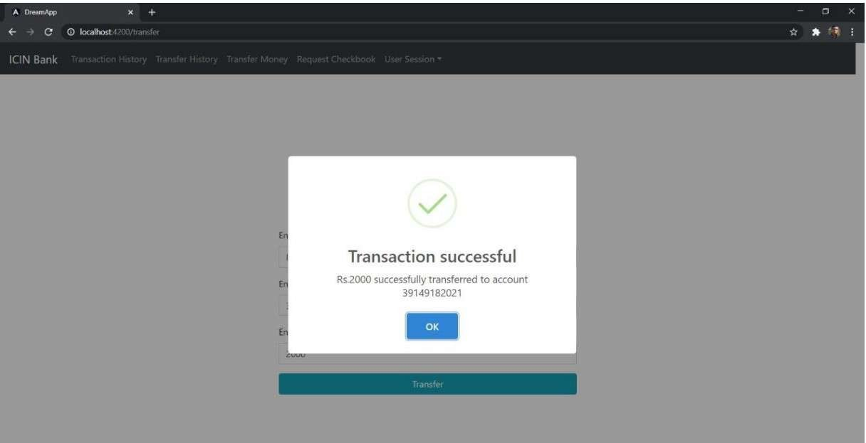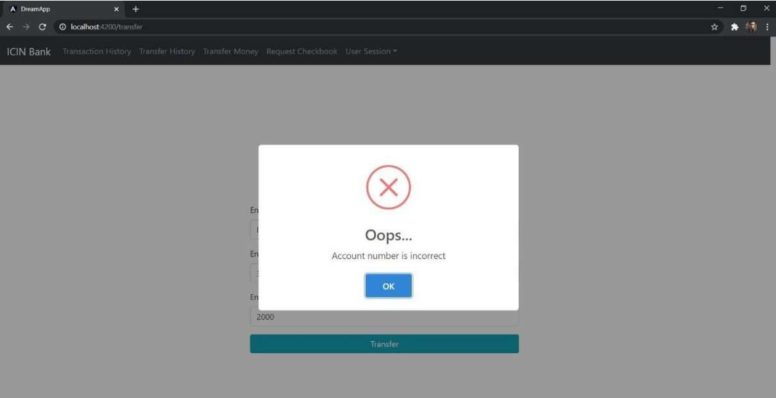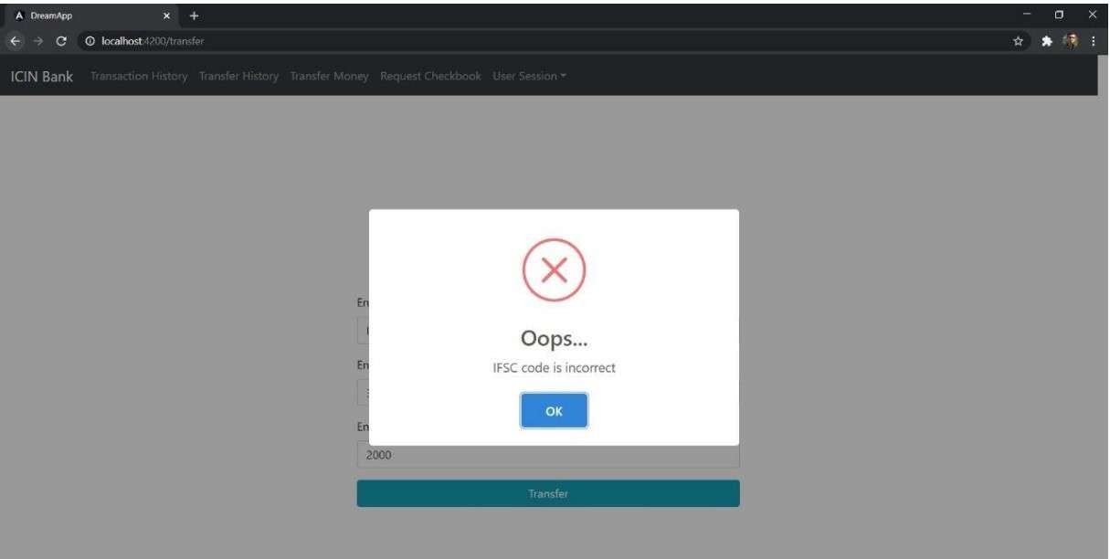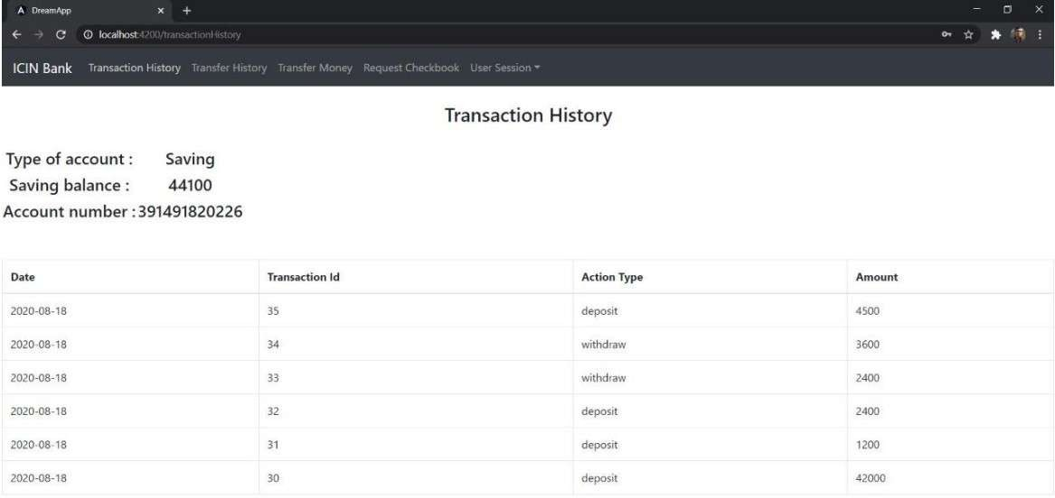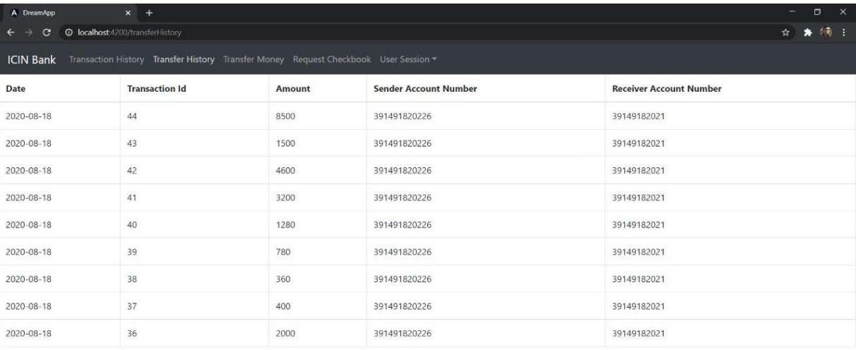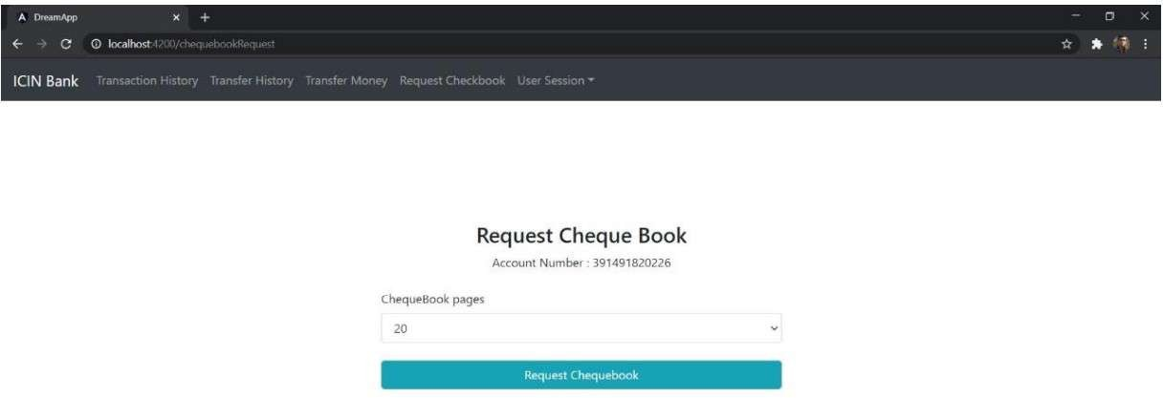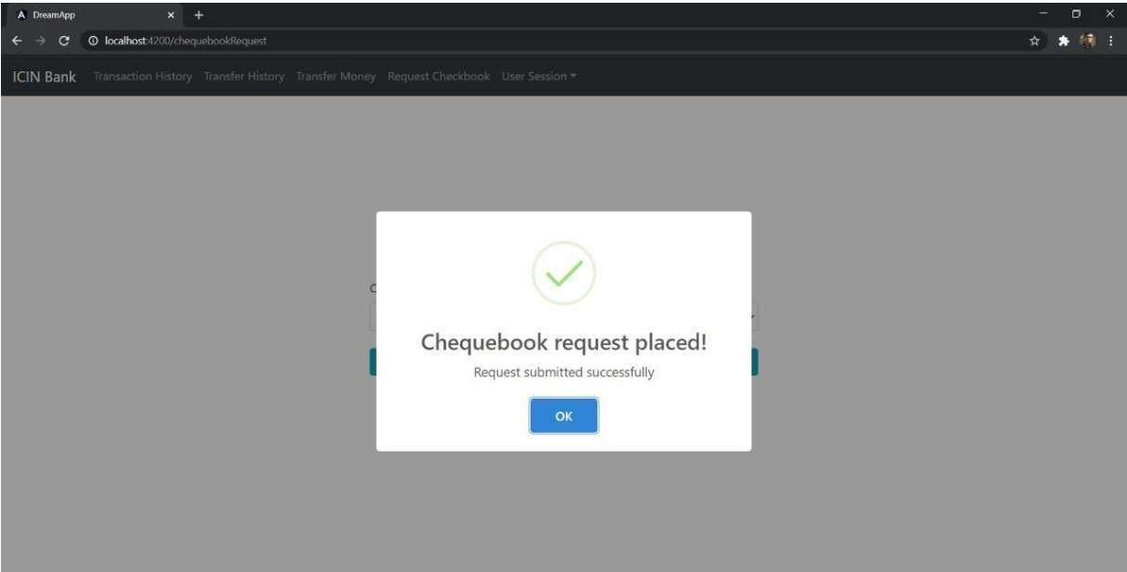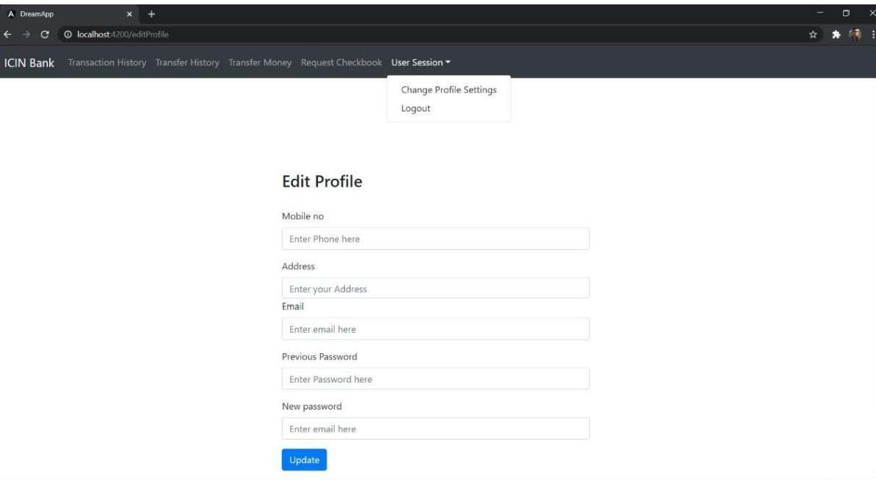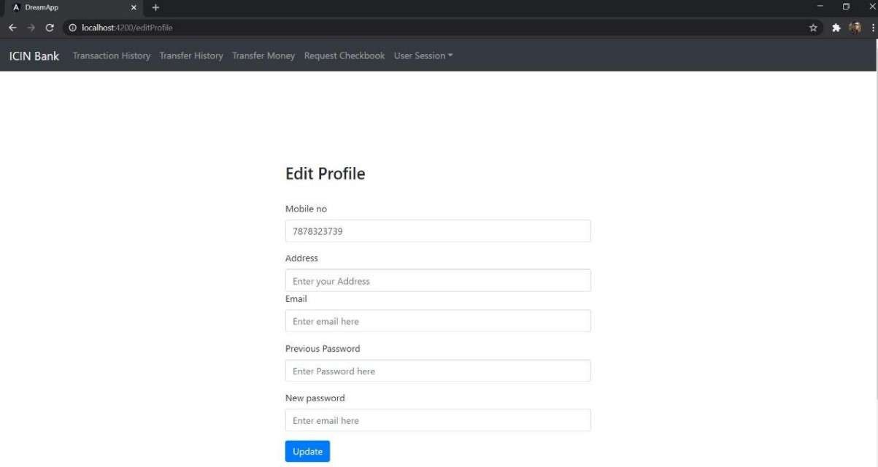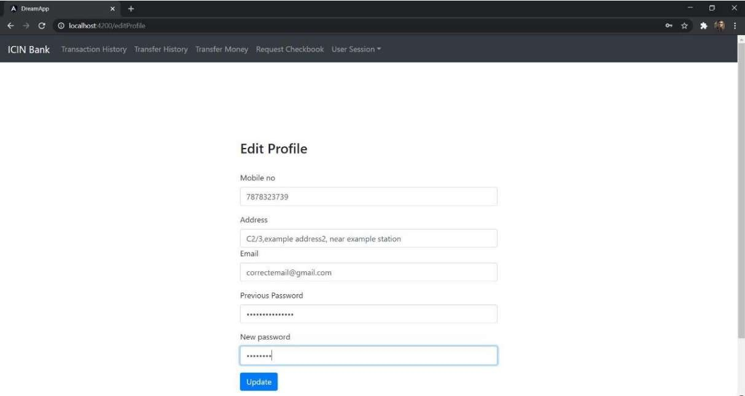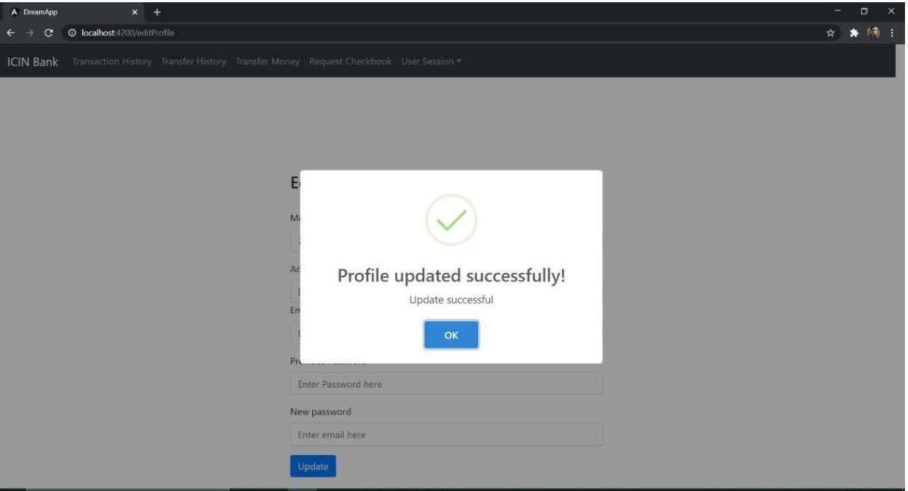

**Links to the GitHub repository to verify the project completion**

## **Pushing the code to GitHub repository**

* Open your command prompt and navigate to the folder where you have created your files.

**cd <** **D:\ICIN Bank\File>**

* Initialize repository using the following command:

**git init**

* Remote add the repository using the following command

**https://github.com/Mogilisanthi/Simplilarn-Phase-7-ICIN-Bank-Project.git**

* Add all the files to your git repository using the following command:

**git add .**

* Commit the changes using the following command:

**git commit . -m “ICIN Bank project”**

* Push the files to the folder you initially created using the following command:

**git push -u origin master**